*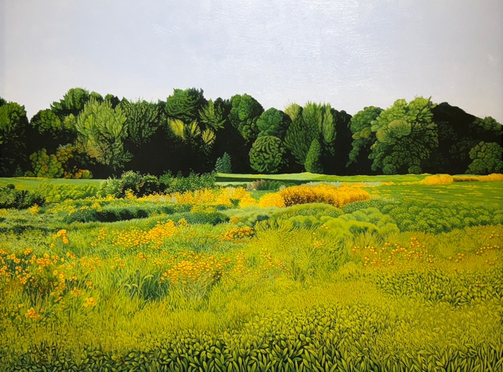****LANDSCAPES***

**April 10 – May 3, 2025**

Gallery Henoch is pleased to present *Landscapes*, a group exhibition featuring artists who utilize nature as inspiration. An opening reception will be held Thursday, April 10th from 6-8 PM. The event is free and open to the public.

On view are paintings exploring the earth’s surface in compelling ways. Each artist interprets their surrounding landscape through brushwork that is distinctly their own. Their particular perspectives may stretch or compress space. Some artists handle paint in wide swaths, while others approach it with precision. In their unique iterations, these artists shape a world that feels both familiar yet newly discovered. A strong sense of place is central to the body of work created by each of them.

Land and sea converge in several artists’ paintings. Having spent time both in the French countryside and along the Cape Cod coast, **John Evans** distills seascapes and landscapes down to color and form, commemorating the feeling each scene evokes in him. Greek artist **Ioanna Stefou** paints powerful, highly realistic seascapes of the ocean surrounding the Aegean islands where she resides. **Eric Zener** emphasizes the mysteries of California’s diverse environment through his depictions of foliage, blooming trees, and the turbulent Pacific Ocean.

Traveling throughout rural New York and Maine, **Jon MacAdam** paints luxuriant assemblages of marshes, fields, and rivers, often in plein air. Conversely, **Anita Mazzucca** looks to her own home region in New Jersey to construct detailed landscape paintings where lush trees and shrubbery are balanced alongside manicured lawns and country roads. **Rebecca Stenn’s** work is characterized by her consideration for space and movement. She depicts the vast mountainous Oregon River Valley terrain in clearly delineated, geometric layers.

Gallery Henoch, 555 West 25th St. (between 10th and 11th Ave). Subway: C or E to 23rd St. Hours: Tuesday - Saturday, 10:30 am - 6:00 pm or by appointment. Free and open to the public. Contact the gallery at 1.917.305.0003 or info@galleryhenoch.com for additional information.