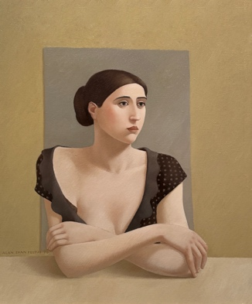
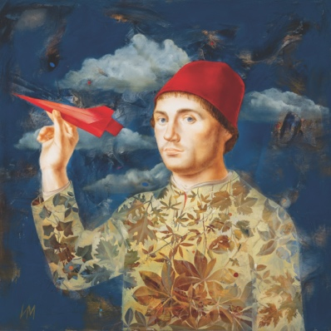
RECENT ACQUISITIONS
May 23 – June 15, 2024

Bo Bartlett
John Evans
Alan Feltus
Igor & Marina
Ben Whitehouse

Gallery Henoch is pleased to present “Recent Acquisitions”, an exhibition featuring six new additions to the gallery collection. The show will run from May 23 to June 15, 2024.

Working as a husband-and-wife team, Igor & Marina paint large scale pieces that position classical figurative subjects in imaginatively patterned settings. An example of their recent work, The Aviator (after Antonello da Messina), evokes Russian iconography while incorporating a backdrop reminiscent of expressionists like Kandinsky and Chagall.

Alan Feltus is an artist who paints spontaneously without prior plans as to his final composition. The Black Dress is an example of his preference for female figures, and illustrates the sculptural quality of his work, which is inspired by classical Greek sculptures and early Renaissance art.

An American realist painter, Bo Bartlett amplifies ordinary moments in human life, making them extraordinary. His paintings are dreamlike narratives, suggesting complex layers of conscious and unconscious meaning. In Fugue, he invites us to contemplate a quietly enigmatic seated woman.

Ioanna Stefou paints sensitive yet highly realistic portraits of girls and women, and, in contrast, powerful seascapes of the ocean surrounding her native Greece. Archontia combines the two, picturing a bathing-suited woman at rest in the shallow ripples of Aegean coastal waters.

Ben Whitehouse combines the landscape tradition of his native Britain with awe for the American countryside, and for the spiritual in art and in nature. His intense concern for the environment can be seen in River, Botanical Gardens, Glencoe, Illinois, where he offers viewers the opportunity to contemplate their relationship to nature.

Also inspired by his surroundings, John Evans creates loosely abstracted landscapes as illustrated in the painting, Beach Parking. He is drawn to bright colors, applying them liberally to his paintings and seeking to create drama among forms that are both planned and impromptu.
Gallery Henoch, 555 West 25th St. (between 10th and 11th Ave). Subway: C or E to 23rd St.
Hours: Tuesday - Saturday, 10:30 am - 6:00 pm or by appointment. Free and open to the public.
Contact the gallery at 1.917.305.0003 or info@galleryhenoch.com for additional information.

